Q Explain Each Diagram with reference to OSI Layer?

# **OSI MODEL**

The Open Systems Interconnection (OSI) model describes seven layers that computer systems use to communicate over a network. It was the first standard model for network communications, the 7 layers of OSI models are:

* Physical Layer.
* Data Link Layer.
* Network Layer.
* Transport Layer.
* Session Layer.
* Presentation Layer.
* Application Layer

**Physical Layer**

Physical layer is responsible for transmitting individual bits from one node to the next node. It defines the relationship between a device and a transmission medium, an example would be a copper or optical cable. This includes the layout of pins, voltages, cable specifications, hubs, repeaters, network adapters, host bus adapters (HBA used in storage area networks) and more

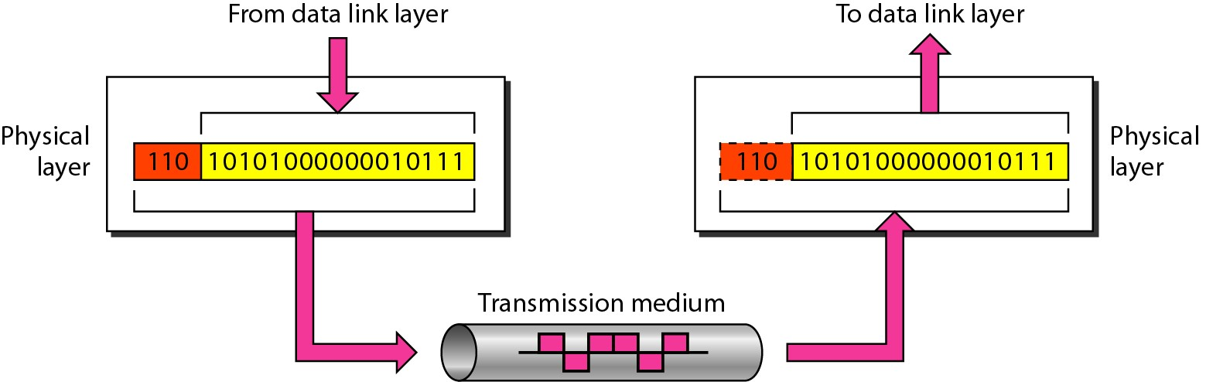

**Data Link Layer**

The data link layer is responsible for transmitting frames from one node to the next. The major duty of a data link layer is to control framing, physical addressing and error handling. As shown in the below figure a node with physical address “A” sends a frame to a node with physical address “B”. The two nodes are connected by a link. At the data link level this frame contains physical addresses in the header. These are the only addresses needed. The rest of the header contains other information needed at this level. The trailer usually contains extra bits needed for error detection. Example of data link layer are **Point-to-Point Protocol (PPP), HDLC and ADCCP**.

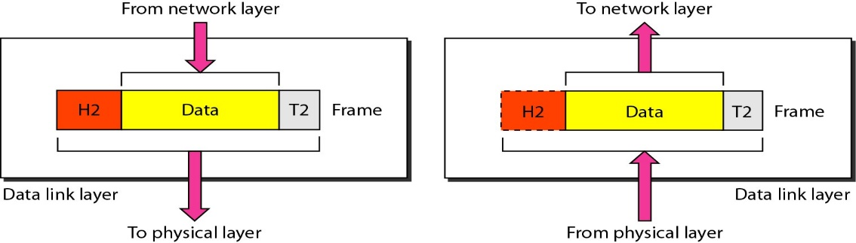

**Network Layer**

The network layer is responsible for the delivery of packets from the original source to the final destination. This layer determines how data is sent to the receiving device. It’s responsible for packet forwarding, routing, and addressing.

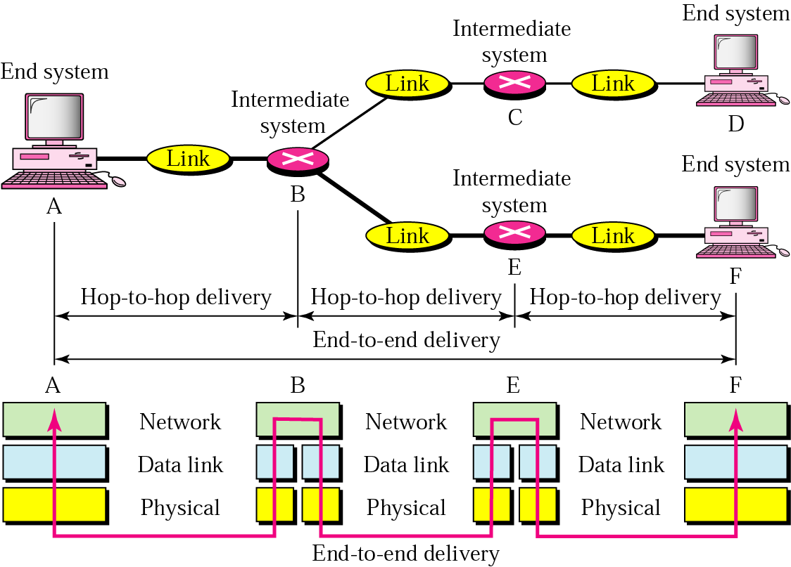

**Transport Layer**

The transport layer is responsible for delivery of a message from one process to another. Transport Layer is the **Transmission Control Protocol (TCP)**, which is built on top of the Internet Protocol (IP), commonly known as TCP/IP.

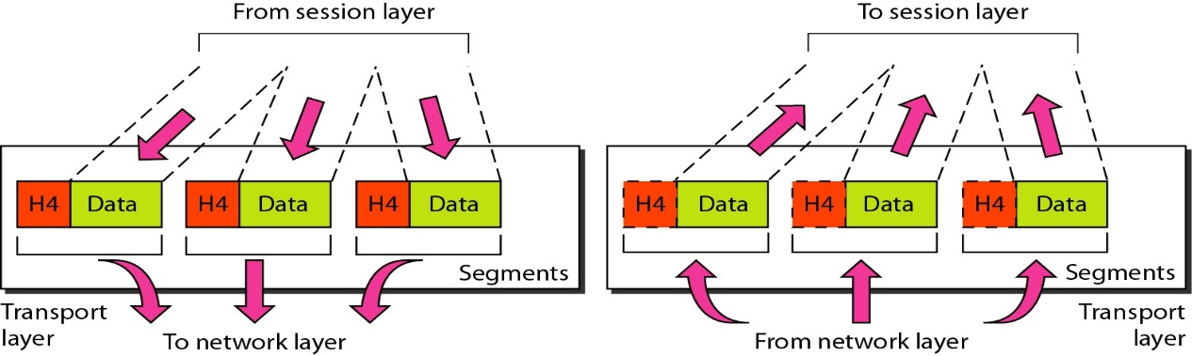

**Presentation Layer**

The presentation layer prepares data for the application layer. It defines how two devices should encode, encrypt, and compress data so it is received correctly on the other end. The presentation layer takes any data transmitted by the application layer and prepares it for transmission over the session layer.

**Session Layer**

The session layer creates communication channels, called sessions, between devices. It is responsible for opening sessions, ensuring they remain open and functional while data is being transferred, and closing them when communication ends. The session layer can also set checkpoints during a data transfer—if the session is interrupted, devices can resume data transfer from the last checkpoint.

**Application Layer**

The application layer is responsible for providing services to the user.

The application layer is used by end-user software such as web browsers and email clients. It provides protocols that allow software to send and receive information and present meaningful data to users. A few examples of application layer protocols are the Hypertext Transfer Protocol (HTTP), File Transfer Protocol (FTP), Post Office Protocol (POP), Simple Mail Transfer Protocol (SMTP), and Domain Name System (DNS).

The major duties of the application layer are

* Mail services
* File transfer and access
* Remote log-in
* Accessing the World Wide Web

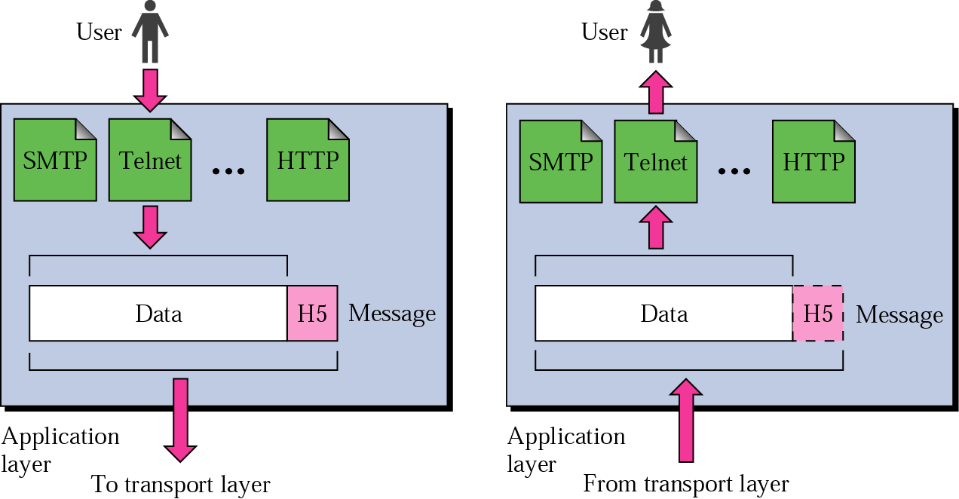

**Figure 1.0**

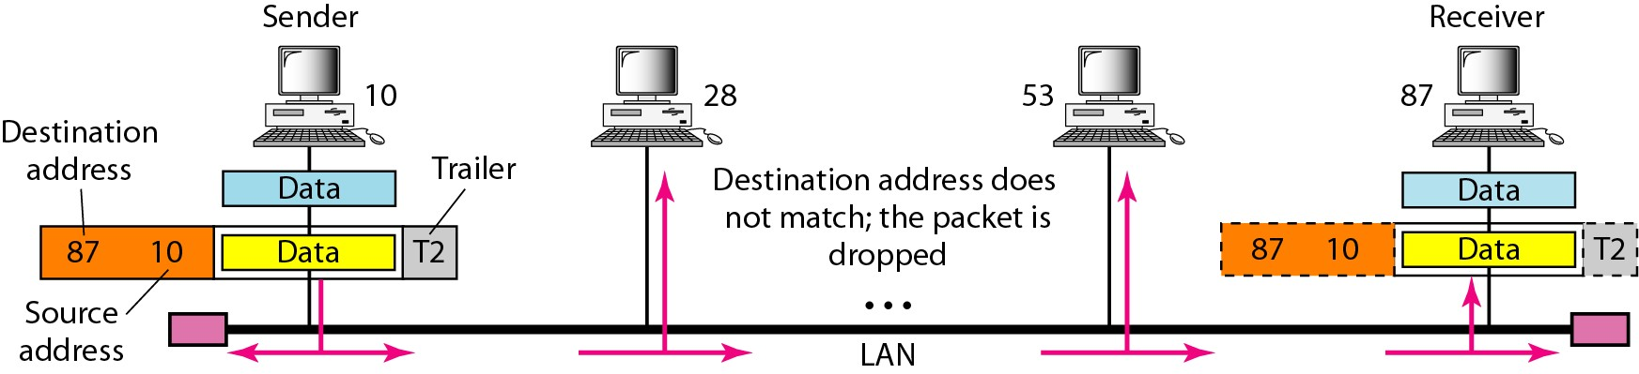

A node with physical address 10 sends a frame to a node with physical address 87. The two nodes are connected by a link (bus topology LAN). As the figure shows, the computer with physical address 10 is the sender, and the computer with physical address 87 is the receiver.

**Figure 2.0**

It shows a part of an internet with two routers connecting three LANs. Each device (computer or router) has a pair of addresses (logical and physical) for each connection. In this case, each computer is connected to only one link and therefore has only one pair of addresses. Each router, however, is connected to three networks (only two are shown in the figure). So each router has three pairs of addresses, one for each connection.

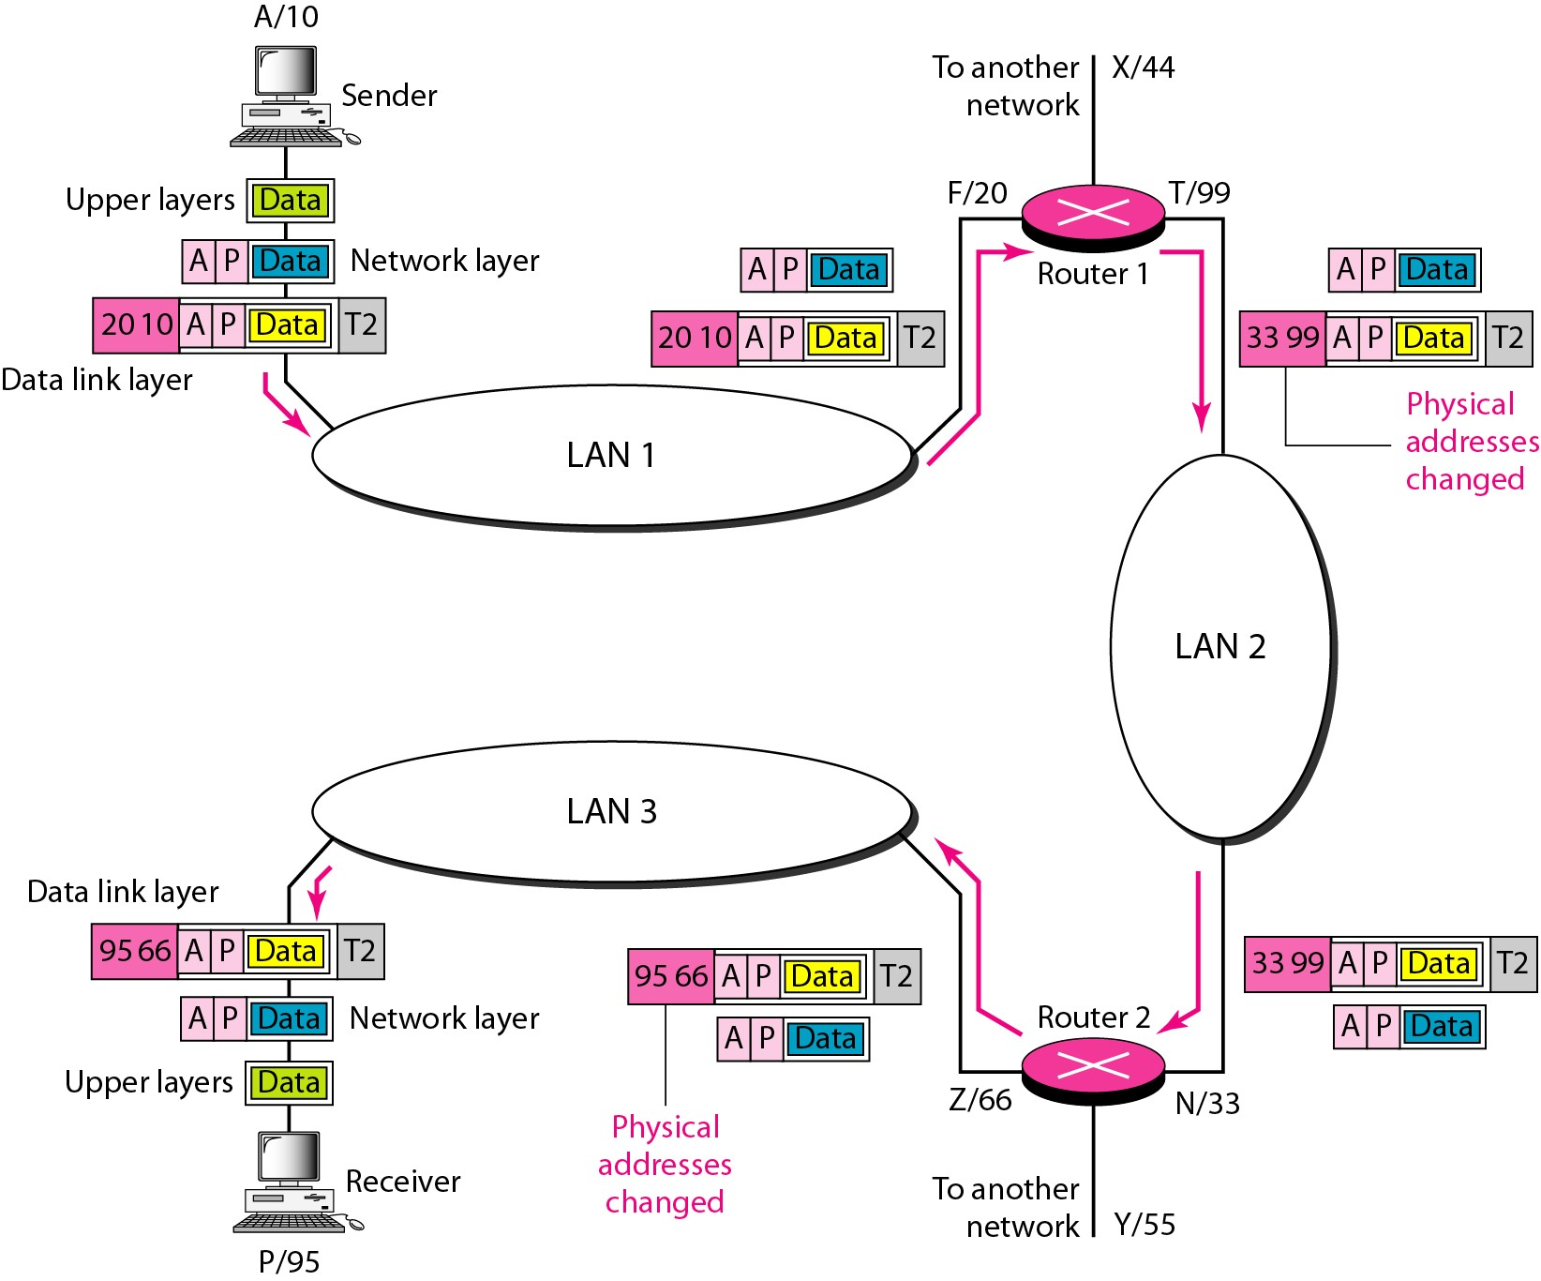

It shows a part of an internet with two routers connecting three LANs. Each device (computer or router) has a pair of addresses (logical and physical) for each connection. In this case, each computer is connected to only one link and therefore has only one pair of addresses. Each router, however, is connected to three networks (only two are shown in the figure). So each router has three pairs of addresses, one for each connection.

**Figure 3.0**

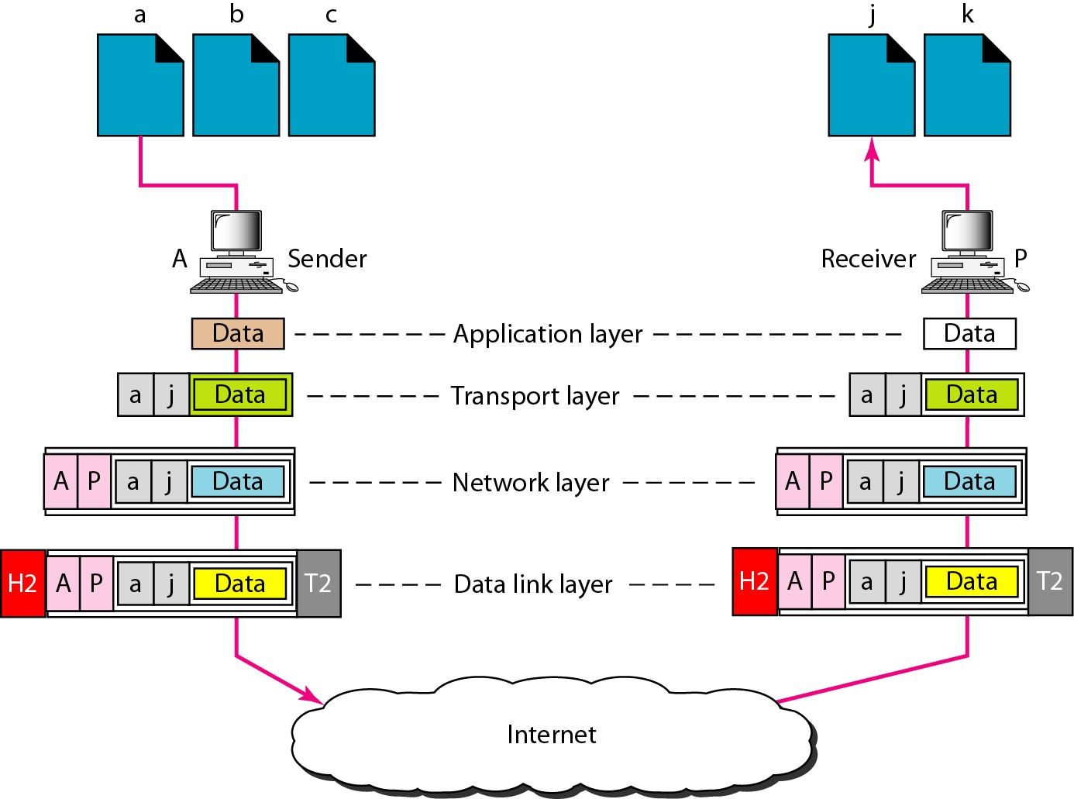

It shows two computers communicating via the Internet. The sending computer is running three processes at this time with port addresses a, b, and c. The receiving computer is running two processes at this time with port addresses j and k. Process a in the sending computer needs to communicate with process j in the receiving computer. Note that although physical addresses change from hop to hop, logical and port addresses remain the same from the source to destination.